

American International University- Bangladesh

CSC 4261: Advanced Programming in Web

CO2 Evaluation

Project Report

Summer 22-23

Project Title: Interstellar-Library: A book selling platform

Section: B

Group: 9

|  |  |
| --- | --- |
| Student Name | Student Id |
| Das, Sudipta Kumar | 20-43658-2 |
| Bhuiyan, MD Mohituzzaman | 20-42546-1 |
| Parvez, Md. Najmus Shakib Khasru | 20-43548-1 |
| Mahmud, Md Abdullah All | 20-44134-2 |

**Introduction:**

An online marketplace for books called Interstellar-Library brings together Customers and sellers from around the globe. Interstellar-Library delivers a smooth experience for both Customers and sellers because to its user-friendly layout and cutting-edge features. A built-in messaging system makes it simple for sellers to offer their books for sale with all the necessary details, manage their listings, collect payments, and get in touch with possible customers. Using a variety of search criteria, customers may find books, explore listings by category, price, location, and condition, add goods to their shopping carts, and complete a secure checkout. In order to maintain a secure and equitable environment for all users, administrators and moderators may oversee and watch over the platform's content, users, transactions, and policies. Join Interstellar-Library today to browse our vast selection of reasonably priced used books.

**Problem Analysis:**

* Problem Statement:

The absence of a trustworthy and user-friendly marketplace for buying and selling used books is the issue that Interstellar-Library seeks to address. Many people have libraries of books they no longer use, while others are seeking for inexpensive ways to purchase out-of-print or hard-to-find literature. Existing solutions, however, are sometimes difficult to use, rife with dishonest vendors, and lacking in details about the books being offered.

* Significance of Solving the Problem:

This issue is resolved by Interstellar-Library, which offers a safe, dependable, and straightforward platform that links Customers and sellers of used books all over the world. The platform provides sophisticated features that make it simpler for sellers to display their books and for Customers to locate what they're searching for, such as comprehensive book information, various payment choices, a message system, and analytics tools. Interstellar-Library encourages sustainability by encouraging

Feature Analysis:

1. User Category:

There are 4-types of Users here. They are:

(4 users)

* Seller
* Customer
* Administrator
* Moderator

1. Feature List:

In this project the “Seller” has the following features:

(**12 feature per user)**

* Add books for sale: Allow sellers to add books for sale with details such as title, author, ISBN, condition, price, and location.
* View their respected listings.
* Edit their Books information’s.
* Delete their Book information’s.
* View sales history: Allow sellers to view their sales history, including sales made, revenue earned, and fees charged.
* View feedback from Customers
* Feedback: Allow Seller to leave feedback for Admin.
* Update Profile: Allow sellers to manage their account settings, including profile picture, contact information, and notifications.
* Login: Every Seller can login to their accounts
* Logout: Every Seller can logout from their accounts
* Signup: Every Seller can create their accounts
* View All Orders
* View Single Order
* Update Order Status
* Calculate Total Income
* Add Address
* Update Address
* Delete Address
* View Address
* Send OTP in Gmail
* Update Password
* Upload Profile Picture
* View Single Book information’s

In this project the “Customer” has the following features:

* Search books by title or author,
* Search books by ISBN or keyword.
* Browse listings: Allow Customers to browse listings by category, price, location, and condition.
* Add to cart: Allow Customer to add items to their cart and purchase multiple items at once.
* Checkout: Provide a secure checkout process for Customers to complete their purchases.
* Feedback: Allow Customers to leave feedback.
* Wish list: Allow Customers to save their favorites items to a wish list for future reference.
* Login: Every Seller can login to their accounts
* Logout: Every Seller can logout from their accounts
* Signup: Every Seller can create their accounts
* Delete Account: Customer can delete their accounts
* Update Profile: Customer can update their accounts

In this project the “Administrator” has the following features:

(**12 feature per user)**

* Adding Sellers
* Remove Sellers
* Remove Customers
* View Sellers information
* View Customers information
* Update Book Lists
* Delete Book Lists
* View all transactions
* Add Moderators
* Login: Every Seller can login to their accounts
* Logout: Every Seller can logout from their accounts
* Sellers Feedback

In this project the “Moderator” has the following features:

(**12 feature per user)**

* View Sellers feedback
* View Customer feedback
* View Sellers information
* View Customers information
* Delete Book Lists
* Update Sellers information
* Update Customers information
* Login: Every Seller can login to their accounts
* Logout: Every Seller can logout from their accounts
* View all book Lists
* Delete Account
* Update Profile information

**Project Folder Structure Diagram & Descriptions:**

1. **Folder Structure:**

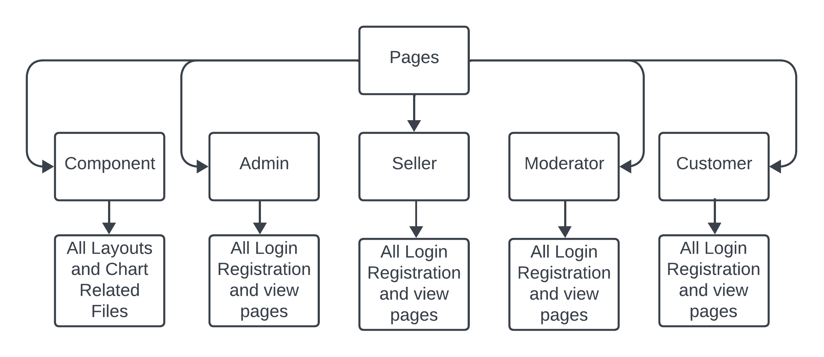

1. **Detailed Structure with Description:**

📦pages

┣ 📂administrator

┣ 📂components

┃ ┣ 📂CalendarView => Calender Components for Mouse hover date show

┃ ┣ 📂Cards => All kinds of Cards Components

┃ ┣ 📂charts => All kinds of Charts Components

┃ ┣ 📂common

┃ ┣ 📂dashboard

┃ ┣ 📂home = Landing Page elements

┃ ┣ 📂images => Images used in frontend Landings

┃ ┣ 📂Input => Input fields as components

┃ ┣ 📂layout

┃ ┃ ┣ 📂seller-layout => All layout Components only for Seller

┃ ┃ ┣ 📂moderator-layout => All layout Components only for Seller

┃ ┃ ┣ 📜_footer.js

┃ ┃ ┣ 📜_header.js

┃ ┃ ┣ 📜_layout.js

┃ ┃ ┣ 📜_navbar.js

┃ ┃ ┗ 📜_title.js

┃ ┣ 📂loading_modal => A modal for Loading to show Delays

┃ ┣ 📂toast => All Toast message components

┃ ┗ 📂Typography

┣ 📂admin => => All Pages used for Admin user

┣ 📂customer => => All Pages used for Customer user

┣ 📂moderator => All Pages used for Moderator user

┣ 📂seller => All Pages used for Seller user

┣ 📂utils => Authentication Works

┣ 📜about-us.js

┣ 📜contact-us.js

┣ 📜index.js

┣ 📜indexCopy.js

┣ 📜_app.js

┗ 📜_document.js

**Git Link:**

<https://github.com/yaarian-om/Interstellar_Library_App>

**Front End:**

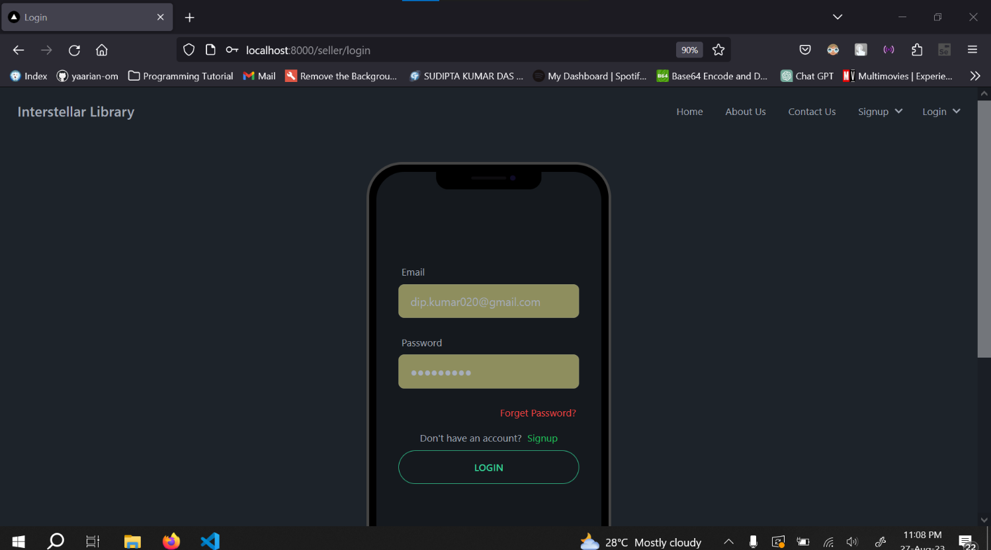

**Figure : Login**

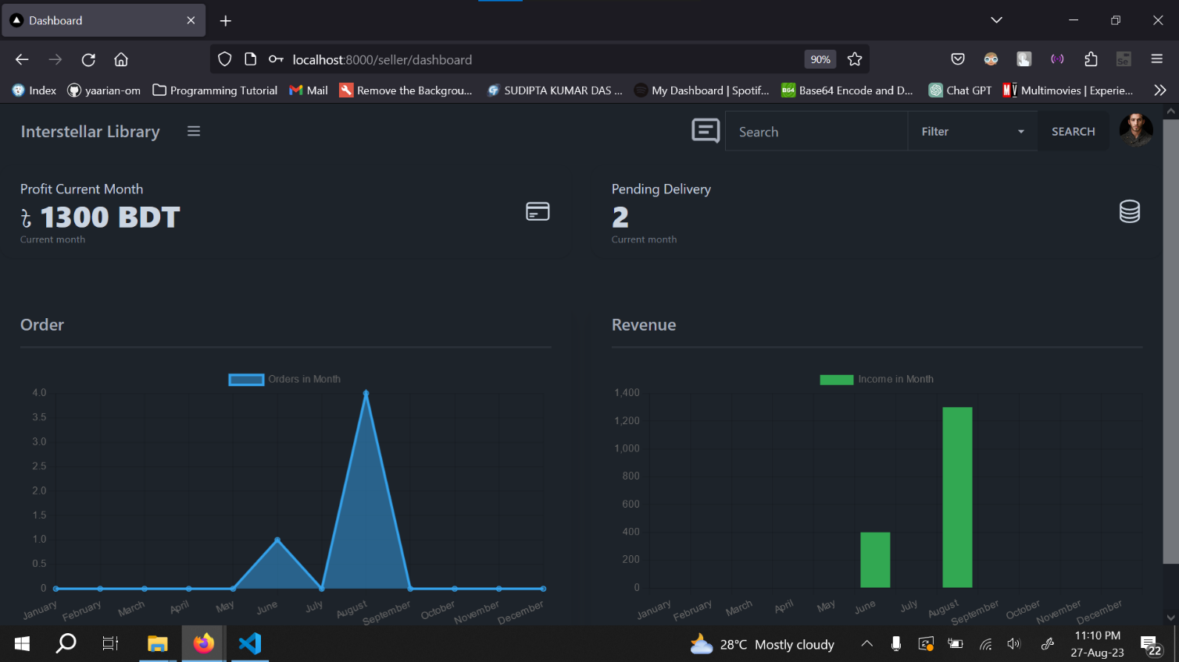

**Figure : Dashboard**

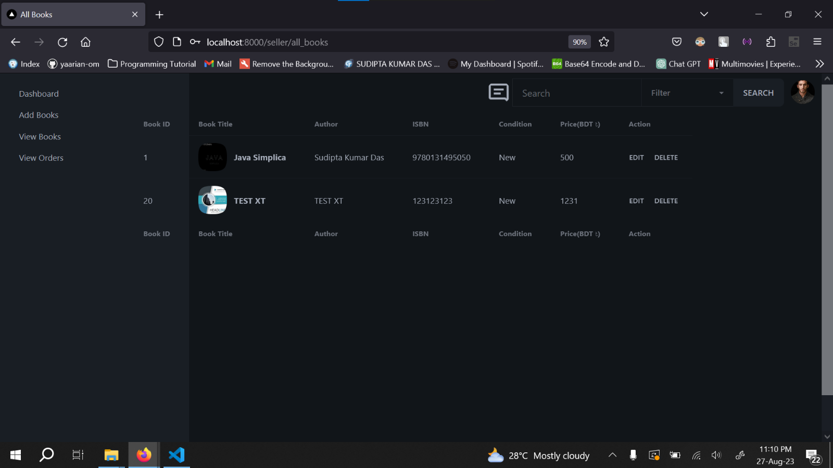

**Figure : Drawer**

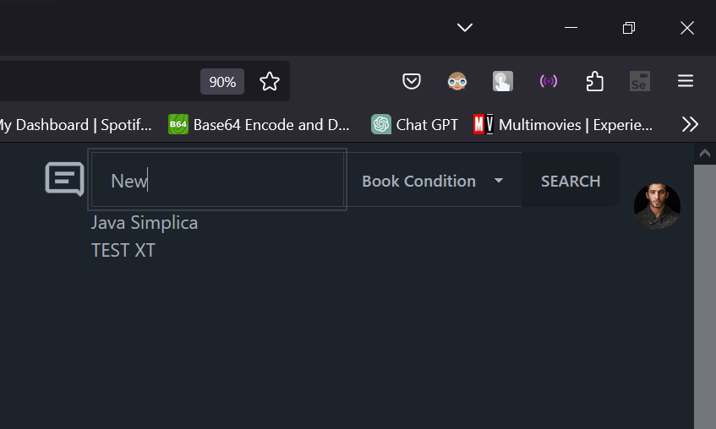

**Figure : Search with Criteria**

|  |  |  |  |  |
| --- | --- | --- | --- | --- |
| CO2 Evaluation: Project & Viva Evaluation | | | | |
| Promptness  (5) | Concept Understanding  (5) | Justification  (5) | Teamwork  (5) | Total (15) |
|  |  |  |  |  |
|  |  | | | |